

**UNIVERSITY OF PETROLEUM & ENERGY STUDIES**

**Dehradun**

**CONTINOUS INTEGRATION**

**AND**

**CONTINOUS DELIVERY**

**Docker Setup**

**Name: Shivani Tyagi**

**Course: B. TECH CSE DevOps (2018-22)**

**Roll no.: R171218097**

**Sapid: 500067253**

**Experiment-12**

## Installation of Docker

* First, in order to ensure the downloads are valid, add the GPG key for the official Docker repository to your system:  
    
  $ curl -fsSL https://download.docker.com/linux/ubuntu/gpg | sudo apt-key add –



* Add the Docker repository to APT sources:

$ sudo add-apt-repository "deb [arch=amd64] https://download.docker.com/linux/ubuntu $(lsb_release -cs) stable"



* Next, update the package database with the Docker packages from the newly added repo:

$ sudo apt-get update

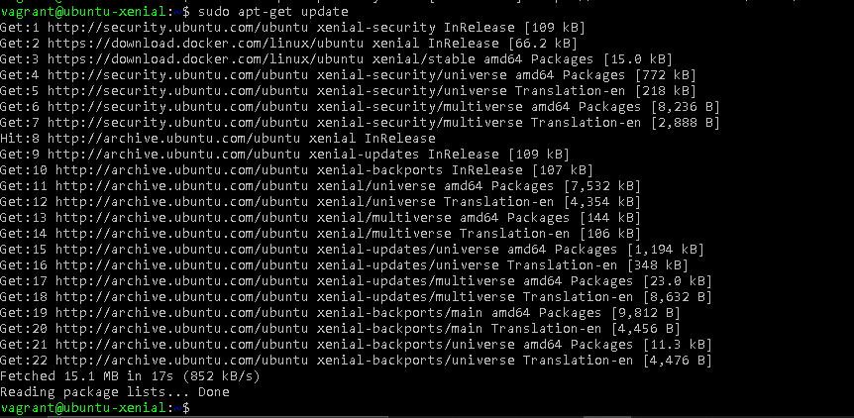

* Make sure you are about to install from the Docker repo instead of the default Ubuntu 16.04 repo:

$ apt-cache policy docker-ce

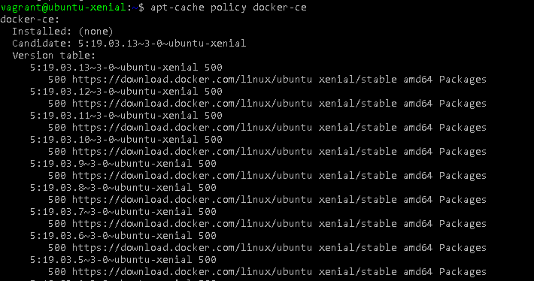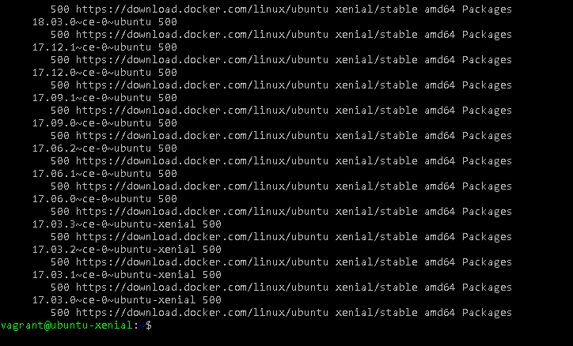

* Finally, install Docker:  
    
  $ sudo apt-get install -y docker-ce

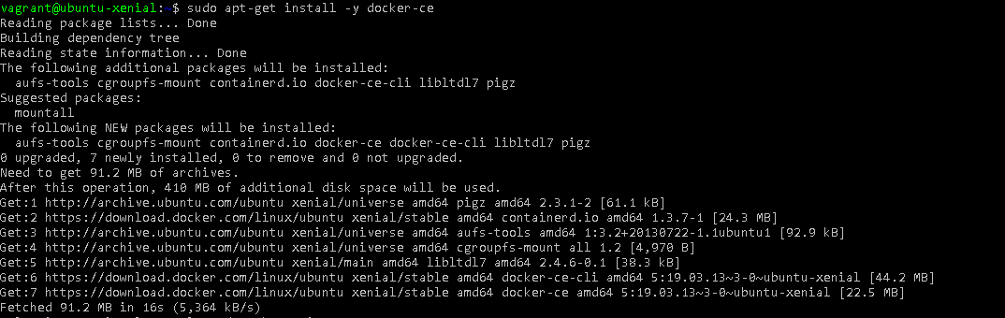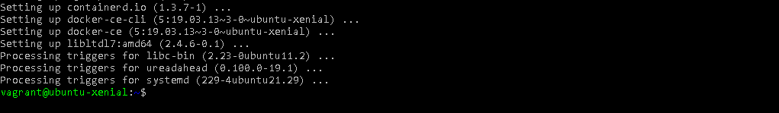

* Check that it’s running:

$ sudo systemctl status docker

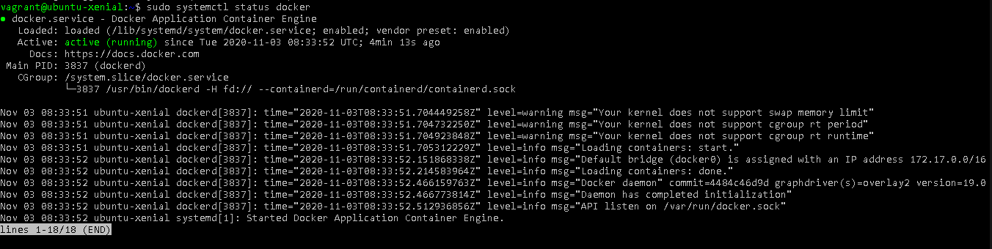

## Configuration

* Executing the Docker Command Without Sudo

If you want to avoid typing sudo whenever you run the docker command, add your username to the docker group:

$ sudo usermod -aG docker ${USER}

